# Short 8-1 Redo a Future Value application with jQuery

In this exercise, you’ll rewrite the code for a Future Value application that uses JavaScript with jQuery. That will show you how jQuery can simplify an application, but also that JavaScript is still needed with jQuery applications. Estimated time: 10 to 15 minutes.

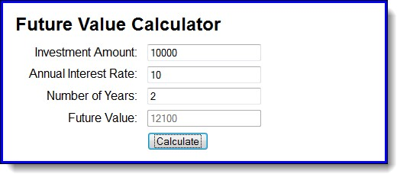

1. Open the HTML and JavaScript files in this folder: **exercises_short\ch08\future_value\**

Then, run the application to refresh your memory about how it works.

1. Add a script element to the HTML file that gives you access to the jQuery library.
2. Rewrite the code in the JavaScript file so it uses as much jQuery as possible. That includes the code for the ready() and click() event methods.
3. When you have the application working right, add a JavaScript statement that moves the focus to the Investment Amount text box each time the Calculate button is clicked.

Guidelines for doing the short exercises

* For all the short exercises, you will start with the HTML, CSS, and JavaScript or jQuery for the application. Then, you will modify the JavaScript or jQuery as directed by the exercise.
* Unless an exercise specifies that you need to modify the HTML or CSS, you won’t have to do that.
* Do the exercise steps in sequence. That way, you will work from the most important tasks to the least important.
* If you are doing an exercise in class with a time limit set by your instructor, do as much as you can in the time limit.
* Feel free to copy and paste code from the book applications or exercises that you’ve already done.
* Use your book as a guide to coding.